Importance of Herbal Medicine
For as long as mankind has thrived within the hills of Appalachia, the resources which exist in the mountains have been used to the advantage of humans who knew of their capabilities. People who later immigrated into the Southern Appalachians from Europe and other distant places, would soon pick up this art of wildcrafting, or the act of gathering herbs and fungi from the wild, and learn to depend upon it as a way of survival. Among these people would include the English, German, Native American, Scots, Irish and Scots-Irish (Cavender). This sliver of knowledge regarding methods of healing which grew all around them offered these folks an advantage over settlers who might not have been so fortunate as to make their home in the mountains. Today, people are still able to take advantage of this age-old healing technique, especially individuals dwelling in an area such as Western North Carolina, where those medicinal types of plants flourish. Herbal Medicine is beginning to become more popular among people, despite how ancient its roots may be. It is important for people to learn how to create this medicine for themselves, as well as learn to utilize the resources around them and learn to live off the land in order to be able to become self-reliant.
The idea of using naturally thriving plants for medicine dates back long before Appalachian people arrived in America. Herbalism goes all the way back to ancient Egypt and Greece, and most importantly, China. In America, the Indians are owed credit for the introduction of this art. “Native American tribes such as the Cherokee and Catawba have been roaming the lush hillsides and gorges for centuries before his time, discovering a multitude of uses for these plants- one of the most significant being medicinal” (Herbal). With the arrival of the white man, Native Americans would pass on the information due to extensive contact and intermarriage between the two races in the area (Cavender). The Native Americans were also willing to help share some of their tips for survival in order to help the newcomers make their way in the new world, and also establish a sense of peace between the two people. “Medicinal plants like Sassafras, Lobelia, Virginia Snakeroot, Slippery Elm, Witch Hazel, and Potato have clear Native American origins and were extensively used by 18th and 19th century physicians and laypeople (Cavender). It is not to be said, however, that the white immigrants had no knowledge on the subject of herbalism beforehand. They took advantage of medicinal plants located within their homeland, and even brought a number of plants with them from the old world and introduced them to the American soil. Among these include Burdock, Catnip, Red Clover, Blackberry, Dandelion, Chickweed, and Plantain (Cavender). Most of these plants are the ones people curse at for invading their lawns and gardens. One example of this is the Plantain. One common name for it is “white man’s foot” indicates that wherever white men traveled and took root, so did Plantain (Garrett). Because people had no option but to live off the land, people of the Appalachian Mountains relied heavily upon the foliage around them. Depending on agriculture is a trend that would continue in the south well after the onset of the industrialization of the 1880’s which was going on up north (Cavender). This method of healing was not only viable for poor commonfolk, but also teas, infusions and poultices made from various plants were also prescribed by most learned physicians, which was true in much of Southern Appalachia well into the 19th century (Cavender).
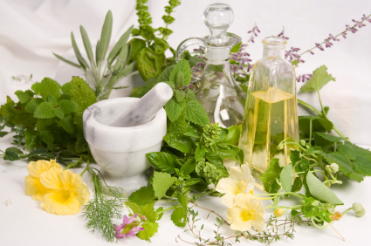
Plants in this region possess thousands of different capabilities for being used medicinally. Among these plants, some of the most common and useful are plants many folks consider to be weeds. for example, a weed called the Plantain can be crushed or chewed and applied topically to soothe bee stings, cuts and scrapes (7). This is a plant that grows right outside the front door, and can be found most anywhere. The oil gained from infusing the flowers of a Mullein plant for several days or weeks relieves the pain of ear infections, as well as soothes eczema and other skin ailments (7). “The dried leaves make an excellent tea or infusion for the lungs- whether it’s to treat an infection or a more chronic condition like asthma” (7). Mullein is an easy to find plant which holds a whole variety of different uses. “The bark of a Wild Cherry tree can be stripped and dried and turned into a cough syrup which can be used as an effective cough suppressant, especially on hectic unproductive coughing” (Meesters). This is why Nyquil and other cough syrups are always cherry flavored! Wild Cherry is an example of one plant that is most productive when used to treat one particular condition. Other plants, such as Ragweed are more versatile. Ragweed can be dried or tinctured and assist with hay fever, allergic reactions, head colds, sinus infections and also acts as an antihistamine” (Meesters). Violets are another instance of this. They are a common plant which can be found anywhere and is also pretty easy to identify. It’s broad uses include a wound healer, mood lightener, soother to the nervous system, respiratory tonic, good for breast health and also yields a large portion of Vitamins A and C, Calcium and Magnesium (Meesters). The uses of backyard plants also go beyond medicine. One plant called Mallow is what the original Marshmallow treat was made from. It sounds like Marshmallow for a reason! Boil the root of the plant in water, add beaten egg whites and sugar and marshmallows are created (7).
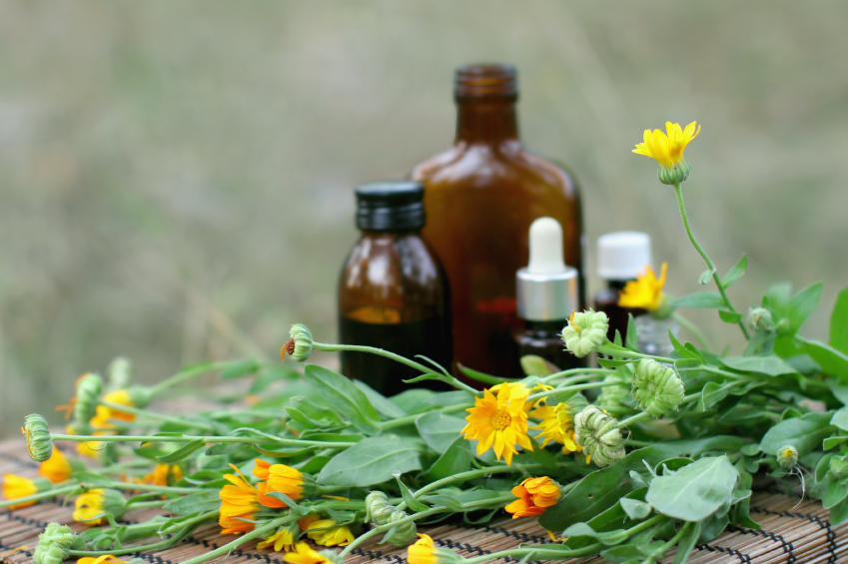
There are precautions that go along with using Herbal medicine and must be taken, just as there would be with using prescription drugs. Foxglove is a plant which is attributed to being an excellent heart medication, keeping millions of heart patients alive (Herbal). “Foxglove is among the loveliest, most famous, most important and most dangerous of medicinal plants. Used improperly it is as likely to stop a heart as it is to keep it going” (Herbal). It is important to be well learned when it comes to the individual plants one is intending to use. Moderation is key, and when in doubt about something it is best to simply refrain from using the plant. However by being uneducated one will miss out on the services the plant might provide. Along with that it is important to “make sure you have positively identified the plant. Many plants in our region have look-alikes- some of these are toxic” (Meesters). It is important that one doesn’t end up causing more harm than healing. Also plants that may contain harmful toxins that may hurt the body are unwanted. “Don’t gather from polluted areas like roadsides, industrial sites, and places where agricultural chemicals might accumulate” (Meesters). Knowing the do’s and don'ts will result in giving one the best possible medicinal treatment and prevent harm from being done.
It is easy to think of Herbalism as an old, outdated method of healing however it is instead a piece of information that humans have been able to better over time. By letting this knowledge slip behind us and into the past, “we ignored and over a short time span nearly relinquished the rich heritage of self care accumulated over centuries that was handed to us by our culture’s ancestral teachers and elder healers” (Green). It is important to educate oneself on other ways of healing the human body. The most common practice seen today is that of antibiotics and extreme drugs and medicines which don’t need to be used in cases of minor illness. “Out of ignorance and media propaganda, many believe this is the only viable system of healing care” (Green). “Innumerable individuals in our Western culture have chosen instead to depend on the pharmaceuticals, surgery and radiation therapy of the allopathic system to treat and suppress the symptoms of their self depleting living habits” (Green). More modernized types of medicine which are capable of producing major effects should only be used in crisis type situations (Green). The more people consume these types of medicine such as antibiotics, the less effective they become because of the body’s natural ability to start to produce an immunity to what it might be commonly exposed to. “Despite increases in the production of synthetic drugs, natural plant drug materials are still economically significant in the United States and large quantities are harvested in the Southern Appalachian region each year for medicinal purposes” (U.S.A). There are still large quantities of people who rely on Herbal medicine as their choice for healing. Not to mention the impact natural plant still have on modern medicine. “40% of all the medicine on the shelves of today’s drugstores have plant origins” (Herbal). People who say that herbal medicine does not work, don’t realize it is part of the drugs they buy in the stores, simply more processed and packed with chemicals and other ingredients. The medicine would be just as effective and much better for humans when used in its natural form. Natural herbs still continue to play a large role in modern medicine of today, even if it is under our noses. “The region is a veritable outdoor pharmacy of medicinal plants which were not only part of the recipes of yesterday's tribal medicine men, but continue to occupy a place in today’s pharmacopeias” (Herbal). “The Southern Appalachian region is home to an incredible variety of plant life. Like anywhere, most of these plants have medicinal properties” (Meesters). Because of the boundless availability of plants in this area, it is important to learn how to take advantage of them. The easy accessibility to these materials makes them a reliable method we can always expect to be able to turn to. Plants and weeds are a highly sustainable resource which have the ability to grow most anywhere and grow quickly. They also own the unique ability to be able to be used in their raw, natural forms. “For there has been and will continue to be healing in the mountains” (Herbal).
Landon Dillingham is an advocate for and avid user of herbal medicine. He is currently a student at Warren Wilson College and works on the herb crew there on the campus. He cares for, harvests and dries plants there so that they may later be made into medicine that can be used and sold. He believes herbal medicine offers an advantage over prescription drugs in the sense that herbal medicine is more easily accessible to common people. Those who have learned how to use this type of medicine are able to locate and use this plant at any time they desire, whereas with prescription drugs, they must be attained through a licensed doctor. Herbal medicine also offers the advantage of being able to build up the body and prevent disease and sickness from occurring in the first place, a quality prescription drugs do not offer. Landon also believes that using the plants and resources available gives people a chance to reconnect with nature, rather than depending upon the unsustainable resource exploitation being relied upon today. As far as the productivity of herbal medicine goes, Landon has personally used them to effectively improve energy levels, strengthen his immunity, relieve symptoms as well as repair from injury. Although he has never had a negative experience, he states the proper precautions still need to be used and users of the medicine need to be well informed in order to prevent having a negative experience, as with any medicine. Living in the southern Appalachian region offers vast opportunity in having access to a wide range of biodiverse resources, according to Landon. In addition to that, this region is blessed with having a vast and innumerable amount of these materials.
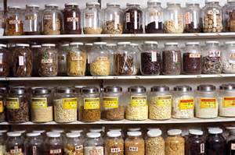
Being knowledgeable of the resources surrounding oneself and the perks the planet offers to humans is an important survival skill. It offers the upper hand of knowing how to help oneself in a time of need. Plants have proved to be reliable, effective and the healthiest choice. “Since prehistoric times, humans have turned to plants for healing, and the quest has not ended in disappointment” (Herbal).

